HW 11

Refer to Chapter 9: Getting Started with JavaScript

Add a screenshot of the source code of the **tny_script.js file** after completing Step 1 on page HTML 736

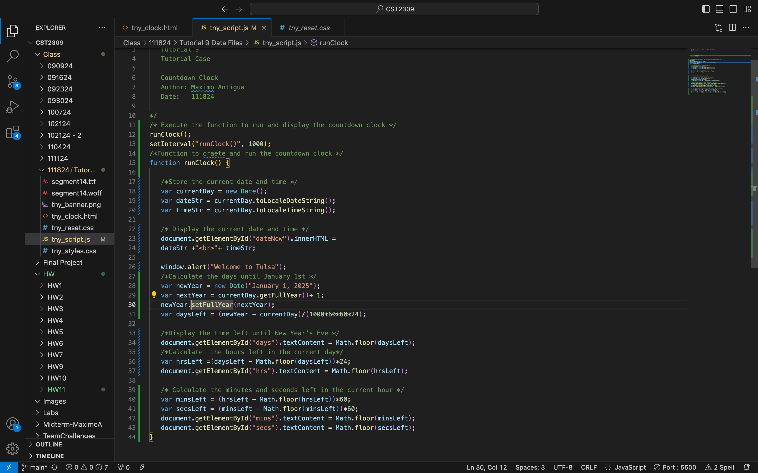

Add a screenshot of the **tny_clock.html file** displayed in your web browser after completing Step 3 on page HTML 736. Include the browser address bar. Show the Current Date and Time , and the countdown clock text generated by JavaScript . Add multiple images to show changing minute and seconds

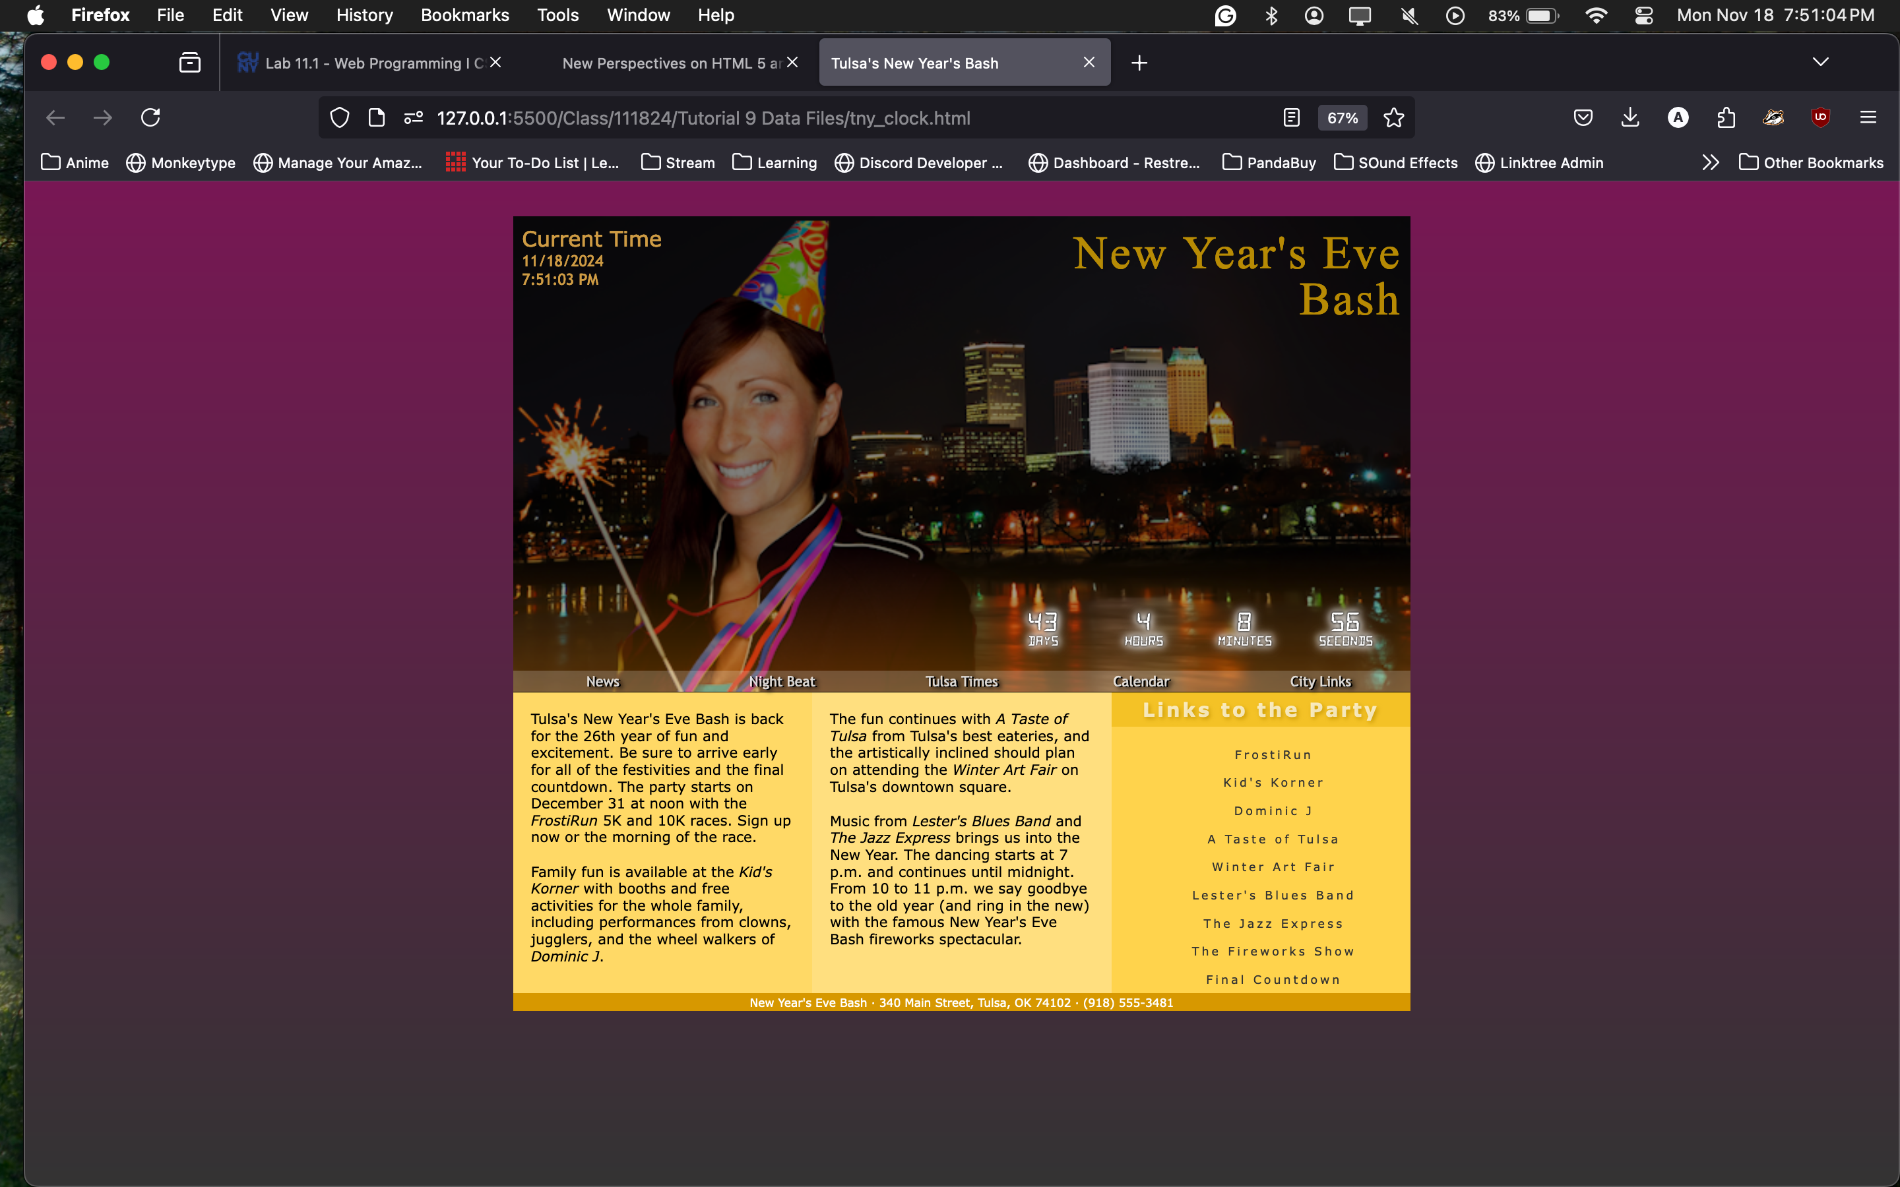

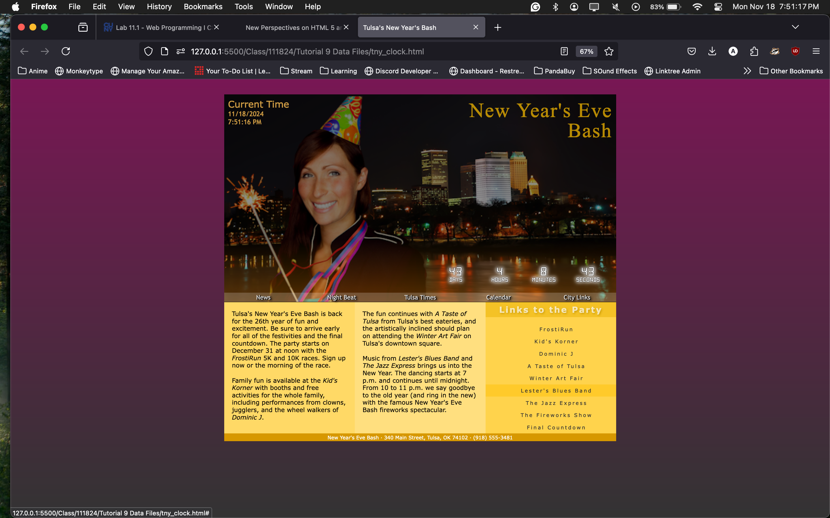

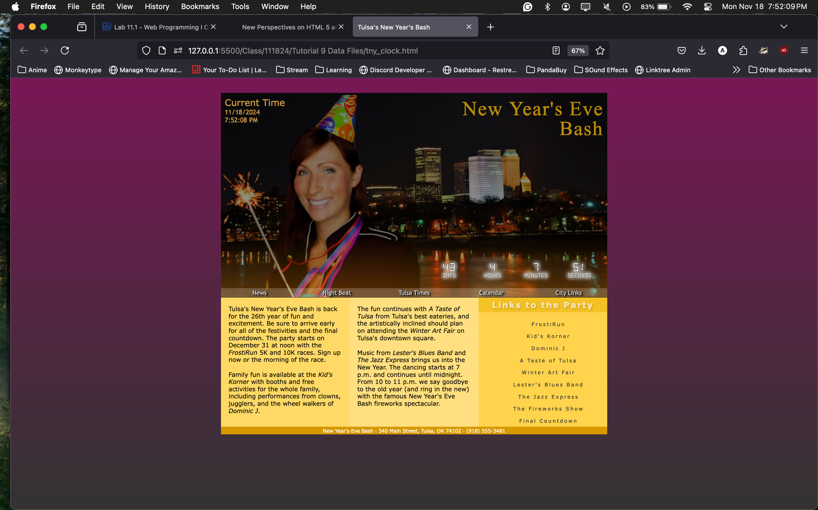

Answer the following questions: Enter a, b, c or d in the shaded area

b

c

a

c